**Assignment4 Output**

1.

Original UI:

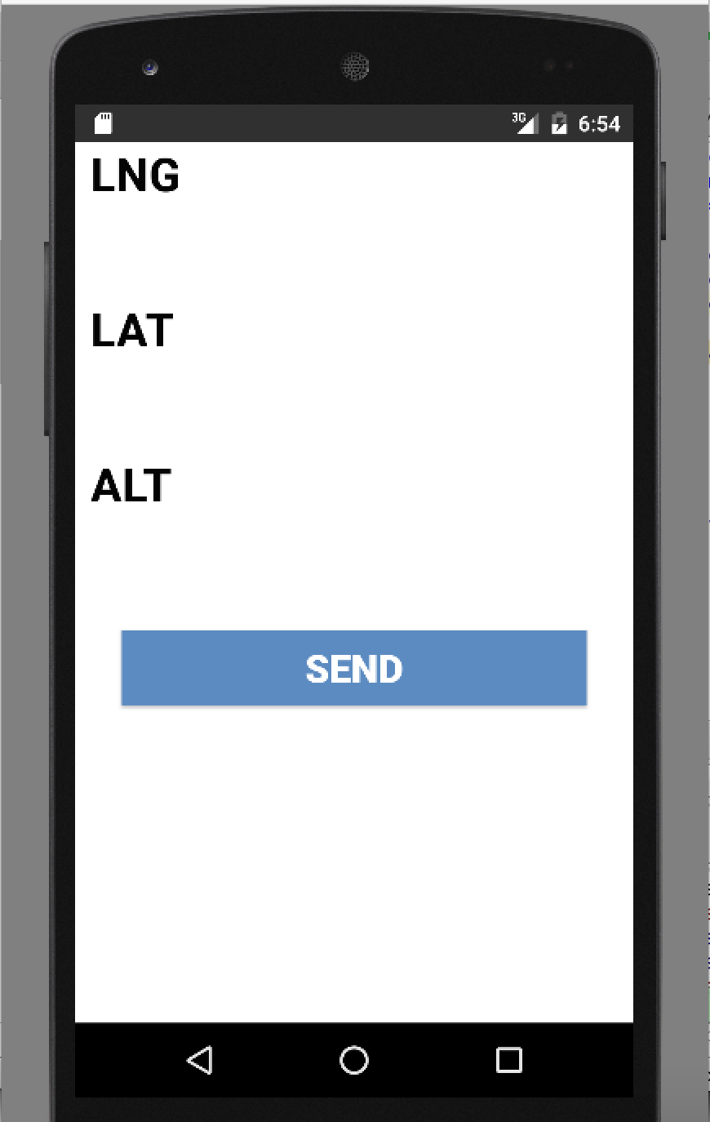

2. Toast Message UI

